Instruction:

Complete all questions in 2 hour.

1. Von Neumann Simulator. This program simulates a very simple computer with the von Neumann architecture.
   1. Download the von Neumann Simulator (VonNeumann.exe) program from google classroom in the Week-7 folder. Save it in your Documents folder and run it. You will see a window similar to this:

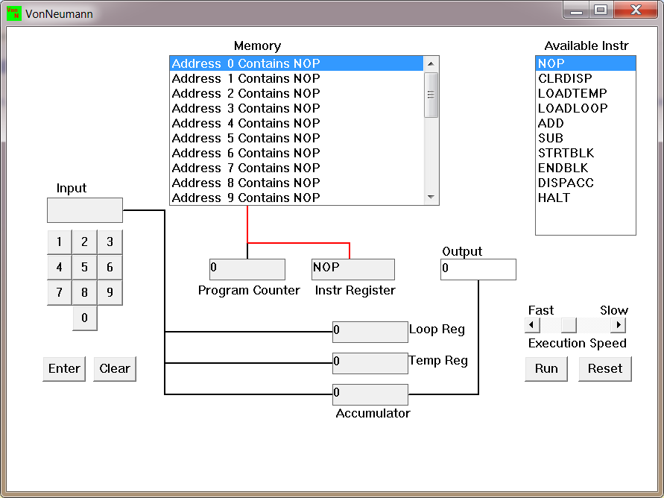

The simulator has a small program memory area which is available for programming. To enter your program instructions simply click on the “Available” instruction on the list on the right and then click on the “Memory” location you wish to put it in.

This simulator understands only the following ten instructions:

|  |  |
| --- | --- |
| NOP | No Operation, i.e. do nothing. |
| LOADTEMP | Get a number from the keypad, completed by the Enter key, into the Temporary Register. |
| LOADLOOP | Get a number from the keypad, completed by the Enter key, into the Loop Register. |
| CLRDISP | Clear the Display. |
| ADD | Add the Temporary Register to the Accumulator |
| SUB | Subtract the Temporary Register from the Accumulator |
| DISPACC | Display the contents of the Accumulator |
| STRTBLK | Start of Loop Block |
| ENDBLK | End of Loop Block |
| HALT | Halt. Stop Program |

* 1. Load the following program in the memory and explain what does the program does?

LOADTEMP – inputs value

ADD-adds value

LOADTEMP-inputs value

ADD-adds value

DISPAAC-display value

HALT-stops program

* 1. Write the program to add three numbers together and explain how does your code works?

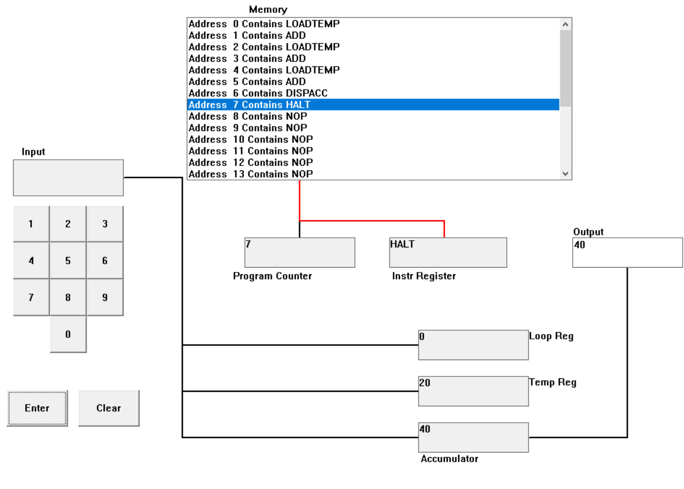

* 1. Write the program to perform

7+3-9

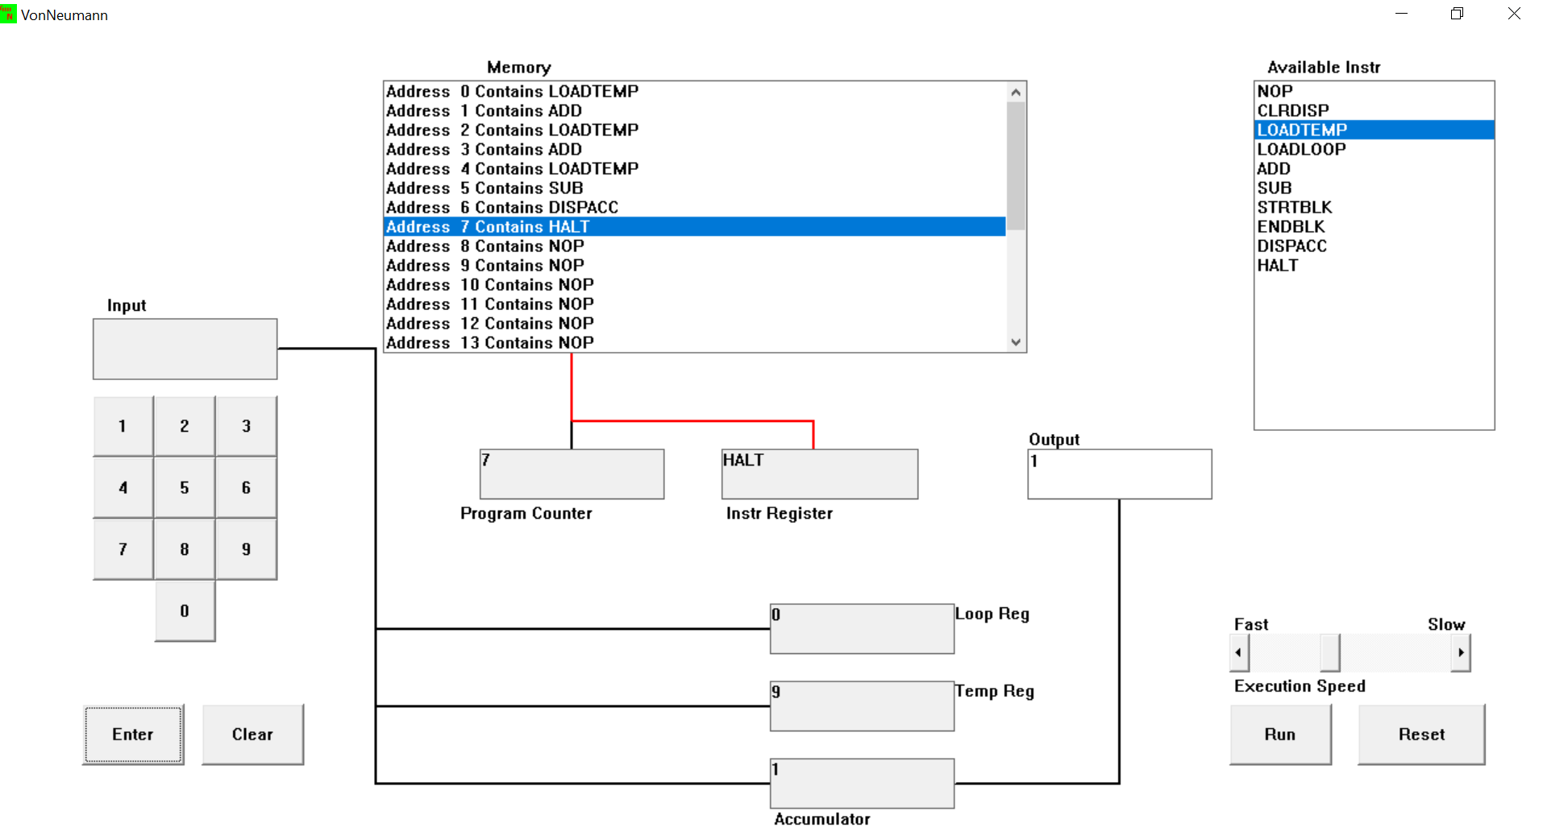

-9+3-7

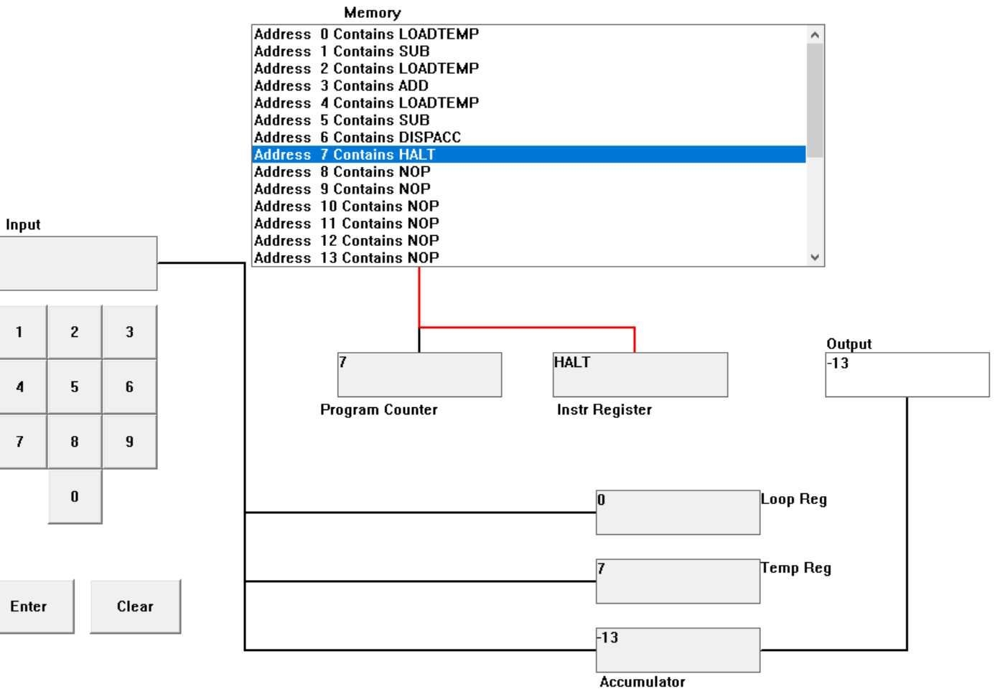

13-7+19

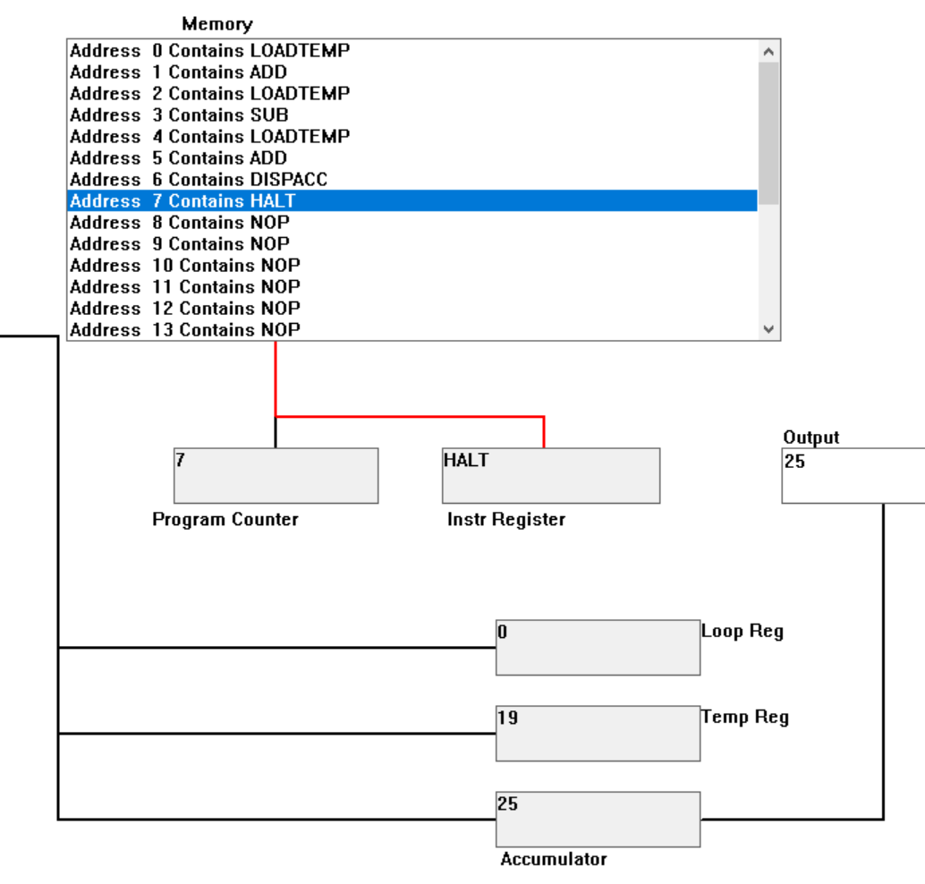

List your code here.

* 1. Write a program to perform

7+(7*3)

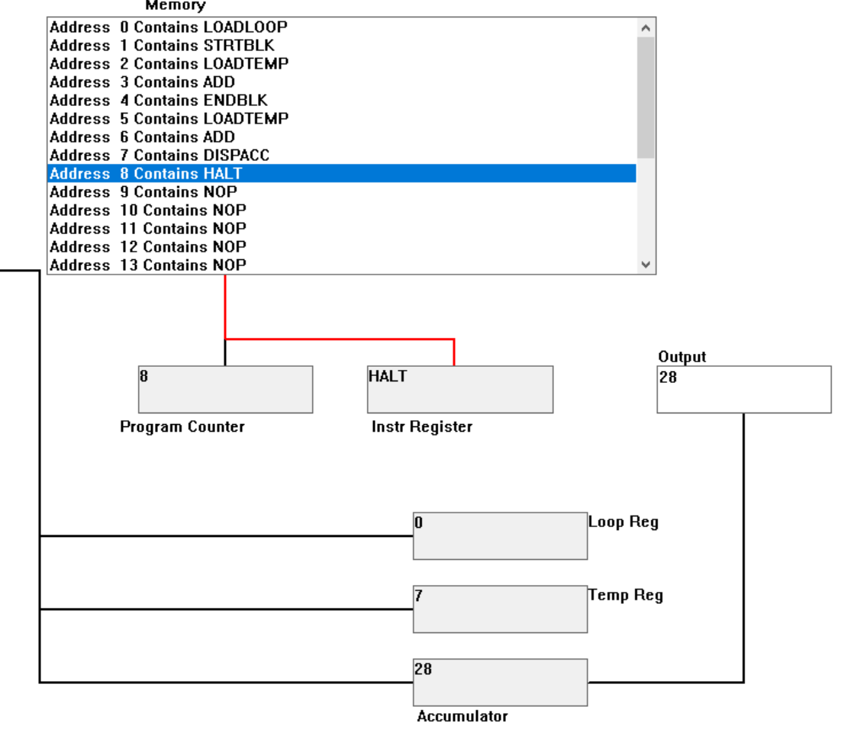

3+(3*7)

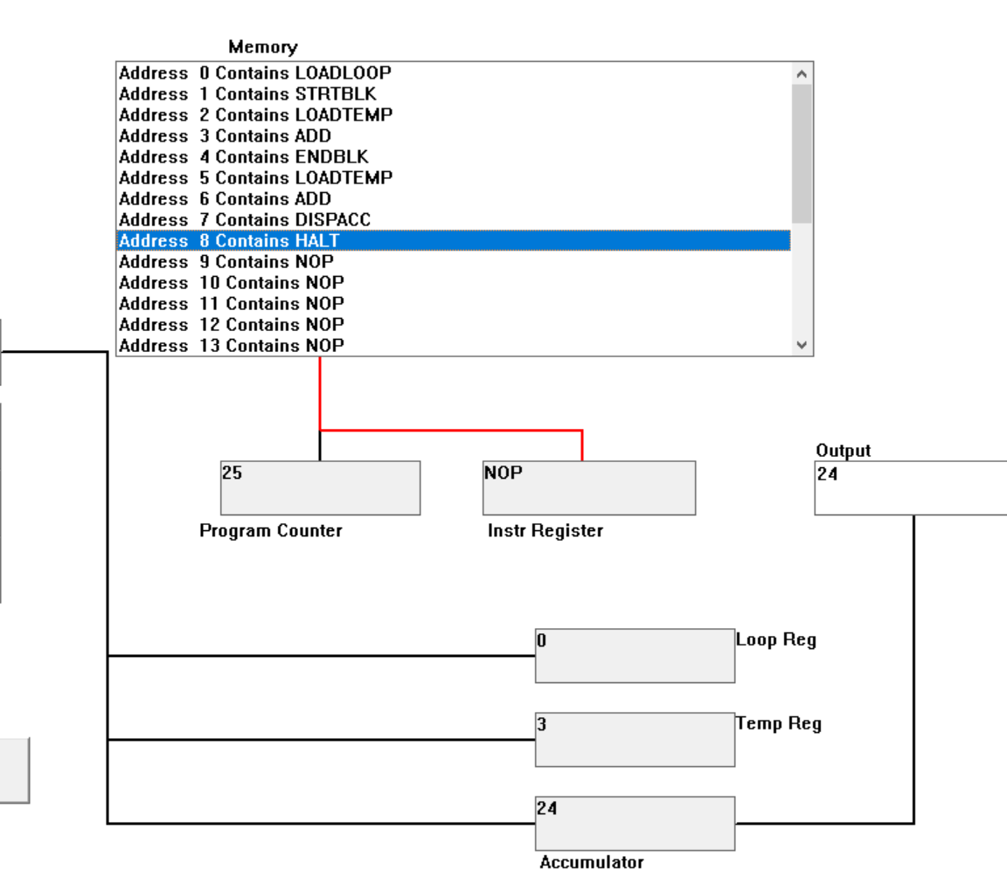

List your code here.

* 1. Write a program to add first 10 natural numbers.

